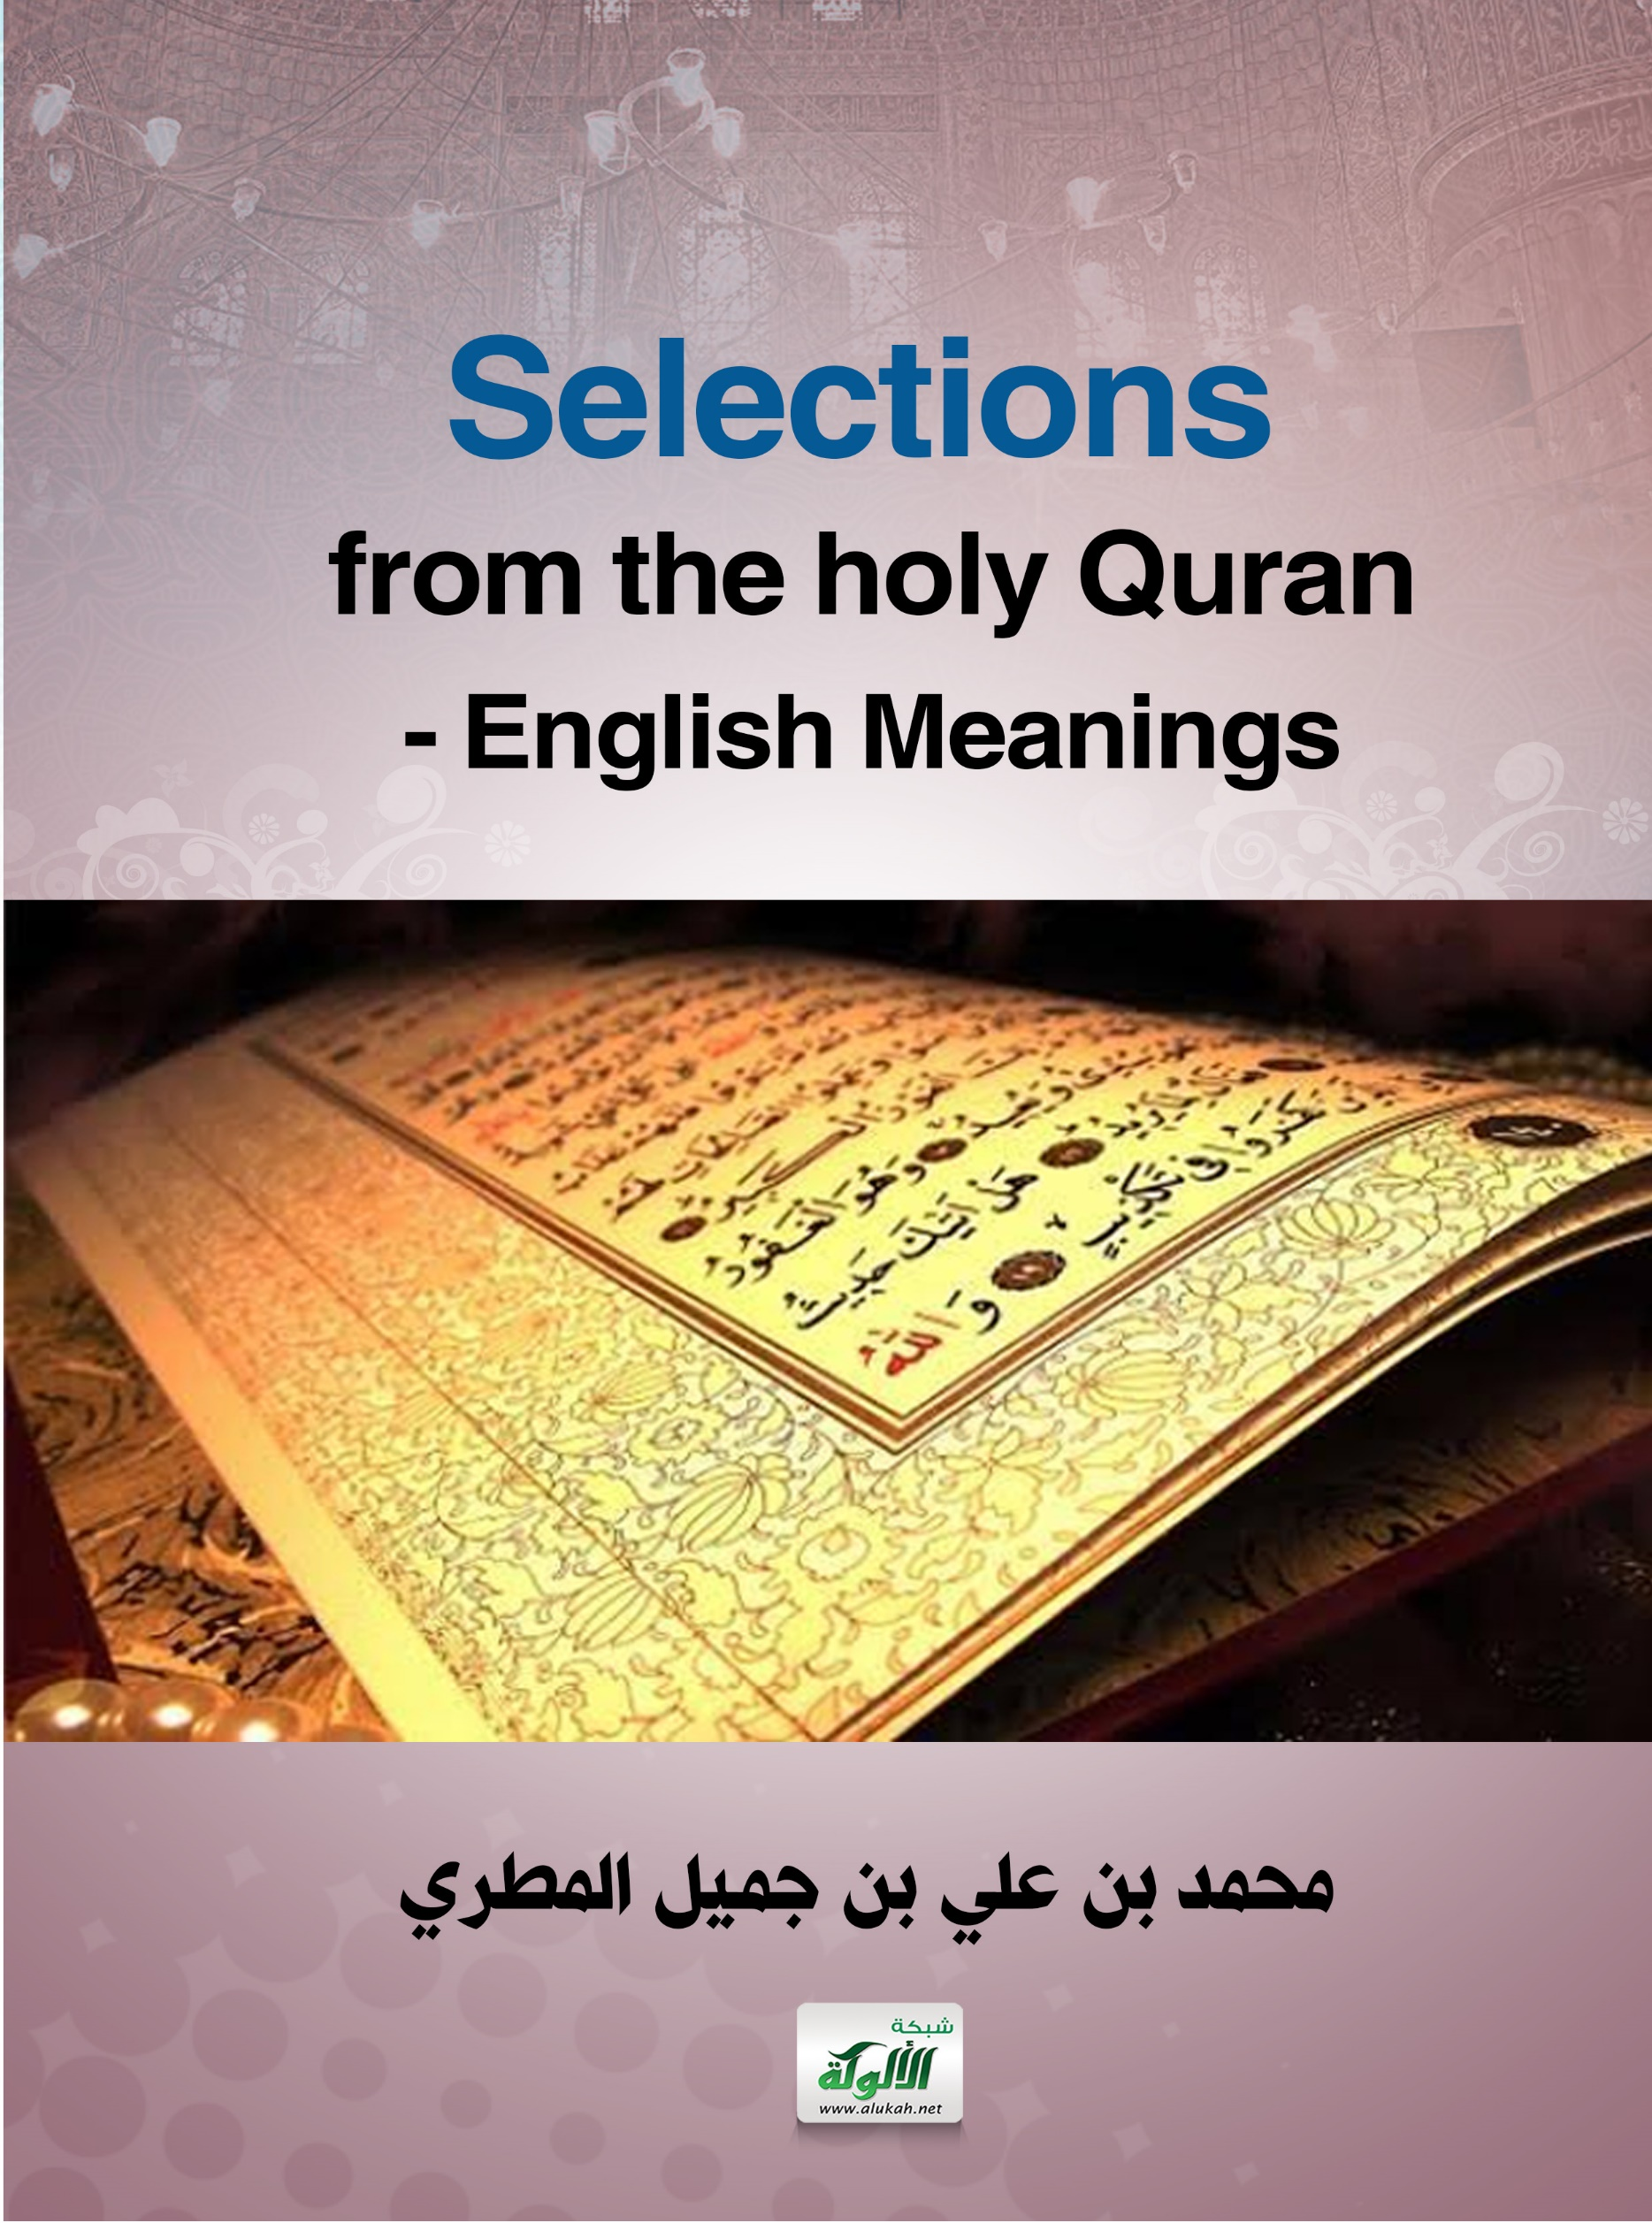
Selections from the holy Quran
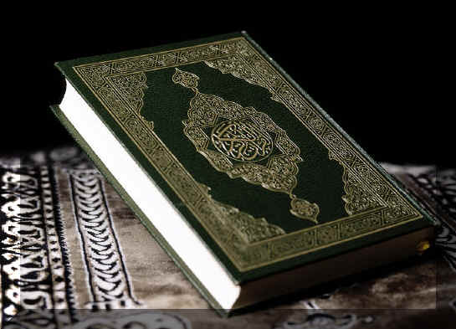

English Meanings

* In the name of Allah, the Entirely Merciful, the Especially Merciful.
. [All] praise is [due] to Allah, Lord of the worlds
. The Entirely Merciful, the Especially Merciful,
. Sovereign of the Day of Recompense.
. It is You we worship and You we ask for help.
. Guide us to the straight path .
. The path of those upon whom You have bestowed favor, not of those who have evoked [Your] anger or of those who are astray.
(1/1-7)

* This is the Book about which there is no doubt, a guidance for those conscious of Allah . Who believe in the unseen, establish prayer, and spend out of what We have provided for them, . And who believe in what has been revealed to you, [O Muhammad], and what was revealed before you, and of the Hereafter they are certain [in faith]. Those are upon [right] guidance from their Lord, and it is those who are the successful.
(2/2-5)

* O mankind, worship your Lord, who created you and those before you, that you may become righteous.
. [He] who made for you the earth a bed [spread out] and the sky a ceiling and sent down from the sky, rain and brought forth thereby fruits as provision for you. So do not attribute to Allah equals while you know [that there is nothing similar to Him].
. And if you are in doubt about what We have sent down [i.e., the Quran] upon Our Servant [i.e., Prophet Muhammad],then produce a surah the like thereof and call upon your witnesses [i.e., supporters] other than Allah, if you should be truthful. But if you do not – and you will never be able to – then fear the Fire, whose fuel is men and stones, prepared for the disbelievers. And give good tidings to those who believe and do righteous deeds that they will have gardens [in Paradise] beneath which
rivers flow. Whenever they are provided with a provision of fruit therefrom, they will say, "This is what we were provided with before." And it is given to them in likeness. And they will have therein purified spouses, and they will abide therein eternally.
(2/21-25)

* And [mention] when We said to the angels, "Prostrate before Adam"; so they prostrated, except for Iblees. He refused and was arrogant and became of the disbelievers.
. And We said, "O Adam, dwell, you and your wife, in Paradise and eat therefrom in [ease and] abundance from wherever you will. But do not approach this tree, lest you be among the wrongdoers."
. But Satan caused them to slip out of it and removed them from that [condition] in which they had been. And We said, "Go down, [all of you], as enemies to one another, and you will have upon the earth a place of settlement and provision for a time."
. Then Adam received from his Lord [some] words, and He accepted his repentance. Indeed, it is He who is the Accepting of repentance, the Merciful.
. We said, "Go down from it, all of you. And when guidance comes to you from Me, whoever follows My guidance – there will be no fear concerning them, nor will they grieve.
. And those who disbelieve and deny Our signs – those will be companions of the Fire; they will abide therein eternally."
(2/34-39)

* And [mention, O Muhammad], when Abraham was tried by his Lord with words [i.e., commands] and he fulfilled them. [Allah] said, "Indeed, I will make you a leader for the people." [Abraham] said, "And of my descendants?" [Allah] said, "My covenant does not include the wrongdoers." . And [mention] when We made the House [i.e., the Kabah] a place of return for the people and [a place of] security. And take,
[O believers], from the standing place of Abraham a place of prayer. And We charged Abraham and Ishmael, [saying], "Purify My House for those who perform tawaf and those who are staying [there] for worship and those who bow and prostrate [in prayer]." And [mention] when Abraham said, "My Lord, make this a secure city and provide its people with fruits – whoever of them believes in Allah and the Last Day." [Allah] said, "And whoever disbelieves – I will grant him enjoyment for a little; then I will force him to the punishment of the Fire, and wretched is the destination." . And [mention] when Abraham was raising the foundations of the House and [with him] Ishmael, [saying], "Our Lord, accept [this] from us. Indeed, You are the Hearing, the Knowing. Our Lord, and make us Muslims [in submission] to You and from our descendants a Muslim nation [in submission] to You. And show us our rites [of hajj and umrah] and accept our repentance. Indeed, You are the Accepting of repentance, the Merciful. Our Lord, and send among them
a messenger from themselves who will recite to them Your verses and teach them the Book and wisdom and purify them. Indeed, You are the Exalted in Might, the Wise."
And who would be averse to the religion of Abraham except one who makes a fool of himself. And We had chosen him in this world, and indeed he, in the Hereafter, will be among the righteous.
. When his Lord said to him, "Submit," he said, "I have submitted [in Islam] to the Lord of the worlds."
. And Abraham instructed his sons [to do the same] and [so did] Jacob, [saying], "O my sons, indeed Allah has chosen for you this religion, so do not die except while you are Muslims."
. Or were you witnesses when death approached Jacob, when he said to his sons, "What will you worship after me?" They said, "We will worship your God and the God of your fathers, Abraham and Ishmael and Isaac – one God. And we are Muslims [in submission]
to Him."
. That was a nation which has passed on. It will have [the consequence of] what it earned, and you will have what you have earned. And you will not be asked about what they used to do.
. They say, "Be Jews or Christians [so] you will be guided." Say, "Rather, [we follow] the religion of Abraham, inclining toward truth, and he was not of the polytheists."
. Say, [O believers], "We have believed in Allah and what has been revealed to us and what has been revealed to Abraham and Ishmael and Isaac and Jacob and the Descendants [al-Asbat] and what was given to Moses and Jesus and what was given to the prophets from their Lord. We make no distinction between any of them, and we are Muslims [in submission] to Him."
. So if they believe in the same as you believe in, then they have been [rightly] guided; but if they turn away, they are only in dissension, and Allah will be sufficient for you against them. And He is the Hearing, the Knowing.
. [And say, "Ours is] the religion of Allah. And who is better than Allah in [ordaining] religion? And we are worshippers of Him."
. Say, [O Muhammad], "Do you argue with us about Allah while He is our Lord and your Lord? For us are our deeds, and for you are your deeds. And we are sincere [in deed and intention] to Him."
. Or do you say that Abraham and Ishmael and Isaac and Jacob and the Descendants were Jews or Christians? Say, "Are you more knowing or is Allah?" And who is more unjust than one who conceals a testimony he has from Allah? And Allah is not unaware of what you do.
. That is a nation which has passed on. It will have [the consequence of] what it earned, and you will have what you have earned. And you will not be asked about what they used to do.
(2/124-141)

*Allah – there is no deity except Him, the Ever-Living, the Sustainer of [all] existence. Neither drowsiness overtakes Him nor sleep. To Him belongs whatever is in the heavens and whatever is on the earth. Who is it that can intercede with Him except by His permission? He knows what is [presently] before them and what will be after them, and they encompass not a thing of His knowledge except for what He wills. His Kursi extends over the heavens and the earth, and their preservation tires Him not. And He is the Most High, the Most Great.
(2/255)

* Indeed, Allah chose Adam and Noah and the family of Abraham and the family of Imran over the worlds.
. Descendants, some of them from others. And Allah is Hearing and Knowing.
. [Mention, O Muhammad], when the wife of Imran said, "My Lord, indeed I have pledged to You what is in my womb,
consecrated [for Your service], so accept this from me. Indeed, You are the Hearing, the Knowing." . But when she delivered her, she said, "My Lord, I have delivered a female." And Allah was most knowing of what she delivered, and the male is not like the female. "And I have named her Mary, and I seek refuge for her in You and [for] her descendants from Satan, the expelled [from the mercy of Allah]."
. So her Lord accepted her with good acceptance and caused her to grow in a good manner and put her in the care of Zechariah.
Every time Zechariah entered upon her in the prayer chamber, he found with her provision. He said, "O Mary, from where is
this [coming] to you?" She said, "It is from Allah. Indeed, Allah provides for whom He wills without account."
. At that, Zechariah called upon his Lord, saying, "My Lord, grant me from Yourself a good offspring. Indeed, You are the Hearer of supplication."
. So the angels called him while he was standing in prayer in the chamber, "Indeed, Allah gives you good tidings of John,
confirming a word from Allah and [who will be] honorable, abstaining [from women], and a prophet from among the righteous."
. He said, "My Lord, how will I have a boy when I have reached old age and my wife is barren?" He [the angel] said, "Such is Allah; He does what He wills."
. He said, "My Lord, make for me a sign." He said, "Your sign is that you will not [be able to] speak to the people for three days except by gesture. And remember your Lord much and exalt [Him with praise] in the evening and the morning. And [mention] when the angels said, "O Mary, indeed Allah has chosen you and purified you and chosen you above the women of the worlds.
. O Mary, be devoutly obedient to your Lord and prostrate and bow with those who bow [in prayer]. That is from the news of the unseen which We reveal to you, [O Muhammad].
And you were not with them when they cast their pens as to which of them should be responsible for Mary. Nor were you with them when they disputed.
. [And mention] when the angels said, "O Mary, indeed Allah gives you good tidings of a word from Him, whose name will be the Messiah, Jesus, the son of Mary –distinguished in this world and the Hereafter and among those brought near [to Allah].
. He will speak to the people in the cradle and in maturity and will be of the righteous."
. She said, "My Lord, how will I have a child when no man has touched me?" [The angel] said, "Such is Allah; He creates what He wills. When He decrees a matter, He only says to it, 'Be,' and it is. And He will teach him writing and wisdom and the Torah and the Gospel . And [make him] a messenger to the Children of Israel, [who will say], 'Indeed I have come to you with a sign from our Lord in that I design for you from clay [that which is] like the form of a bird, then I breathe into it and it becomes a bird by permission of Allah. And I cure the blind [from birth] and the leper, and I give life to the dead – by permission of Allah. And I inform you of what you eat and what you store in your houses. Indeed in that is a sign for you, if you are believers. And [I have come] confirming what was before me of the Torah and to make lawful for you some of what was forbidden to you. And I have come to you with a sign from your Lord, so fear Allah and obey me. Indeed, Allah is my Lord and your Lord, so worship Him.
That is the straight path.' " . But when Jesus felt [persistence in] disbelief from them, he said, "Who are my supporters for [the cause of] Allah?" The disciples said, "We are supporters for Allah. We have believed in Allah and testify that we are Muslims [submitting to Him].
. Our Lord, we have believed in what You revealed and have followed the messenger [i.e., Jesus], so register us among the
witnesses [to truth]." . And they [i.e., the disbelievers] planned, but Allah planned. And Allah is the best of planners. [Mention] when Allah said, "O Jesus, indeed I will take you and raise you to Myself and purify [i.e., free] you from those who disbelieve and make those who follow you [in submission to Allah alone] superior to those who disbelieve until the Day of Resurrection. Then to Me is your return, and I will judge between you concerning that in which you used to differ. And as for those who disbelieved, I will punish them with a severe punishment in this world and the Hereafter, and they will have no helpers."
. But as for those who believed and did righteous deeds, He will give them in full their rewards, and Allah does not like the wrongdoers. This is what We recite to you,
[O Muhammad], of [Our] verses and the precise [and wise] message [i.e., the Quran]. Indeed, the example of Jesus to Allah is like that of Adam. He created him from dust; then He said to him, "Be," and he was. The truth is from your Lord, so do not be among the doubters. Then whoever argues with you about it after [this] knowledge has come to you – say, "Come, let us call our sons and your sons, our women and your women, ourselves and yourselves, then supplicate earnestly [together] and invoke the curse of Allah upon the liars [among us]." . Indeed, this is the true narration. And there is no deity except Allah. And indeed, Allah is the Exalted in Might, the Wise. But if they turn away, then indeed – Allah is Knowing of the corrupters. Say, "O People of the Scripture, come to a word that is equitable between us and you – that we will not worship except Allah and not associate anything with Him and not take one another as lords instead of Allah." But if they turn away, then say, "Bear witness that we are Muslims [submitting to Him]." . O People of the Scripture, why do you argue about Abraham while the Torah and the Gospel were not revealed until after him? Then will you not reason?
. Here you are – those who have argued about that of which you have [some] knowledge, but why do you argue about that of which you have no knowledge? And Allah knows, while you know not. Abraham was neither a Jew nor a Christian, but he was one inclining toward truth, a Muslim [submitting to Allah]. And he was not of the polytheists. Indeed, the most worthy of Abraham among the people are those who followed him [in submission to Allah] and this prophet [i.e., Muhammad ] and those who believe [in his message]. And Allah is the ally of the believers.
. A faction of the People of the Scripture wish they could mislead you. But they do not mislead except themselves, and they perceive [it] not. O People of the Scripture, why do you disbelieve in the verses of Allah while you witness [to their truth]?
. O People of the Scripture, why do you mix [i.e., confuse] the truth with falsehood and conceal the truth while you know [it]?
(3/33-71)

* It is not for a human [prophet] that Allah should give him the Scripture and authority and prophet hood and then he would say to the people, "Be servants to me rather than Allah," but [instead, he would say], "Be pious scholars of the Lord because of what you have taught of the Scripture and because of what you have studied." . Nor could he order you to take the angels and prophets as lords. Would he order you to disbelief after you had been Muslims?
(3/79-80)

* Say, "We have believed in Allah and in what was revealed to us and what was revealed to Abraham, Ishmael, Isaac, Jacob, and the Descendants [al-Asbat], and in what was given to Moses and Jesus and to the prophets from their Lord. We make no distinction between any of them, and we are Muslims [submitting] to Him." . And whoever desires other than Islam as religion – never will it be accepted from him, and he, in the Hereafter, will be among the losers.
(3/84-85)

* The People of the Scripture ask you to bring down to them a book from the heaven. But they had asked of Moses [even] greater than that and said, "Show us Allah outright," so the thunderbolt struck them for their wrongdoing. Then they took the calf [for worship] after clear evidences had come to them, and We pardoned that. And We gave Moses a clear authority.
. And We raised over them the mount for [refusal of] their covenant; and We said to them, "Enter the gate bowing humbly"; and We said to them, "Do not transgress on the Sabbath"; and We took from them a solemn covenant. And [We cursed them] for their breaking of the covenant and their disbelief in the signs of Allah and their killing of the prophets without right and their saying, "Our hearts are wrapped" [i.e., sealed against reception]. Rather, Allah has sealed them because of their disbelief, so they believe not, except for a few.
. And [We cursed them] for their disbelief and their saying against Mary a great slander, . And [for] their saying, "Indeed, we have killed the Messiah, Jesus, the son of Mary, the messenger of Allah." And they did not kill him, nor did they crucify him; but [another] was made to resemble him to them. And indeed, those who differ over it are in doubt about it. They have no knowledge of it except the following of assumption. And they did not kill him, for certain. Rather, Allah raised him to Himself. And ever is Allah Exalted in Might and Wise.
. And there is none from the People of the Scripture but that he will surely believe in him [i.e., Jesus] before his death. And on the Day of Resurrection he will be against them a witness.
. For wrongdoing on the part of the Jews, We made unlawful for them [certain] good foods which had been lawful to them, and for their averting from the way of Allah many [people], . And [for] their taking of usury while they had been forbidden from it, and their consuming of the people's wealth unjustly. And We have prepared for the disbelievers among them a painful punishment.
. But those firm in knowledge among them and the believers believe in what has been revealed to you, [O Muhammad], and what was revealed before you. And the establishers of prayer [especially] and the givers of zakah and the believers in Allah and the Last Day those We will give a great reward.
. Indeed, We have revealed to you, [O Muhammad], as We revealed to Noah and the prophets after him. And We revealed to Abraham, Ishmael, Isaac, Jacob, the Descendants, Jesus, Job, Jonah, Aaron, and Solomon, and to David We gave the book [of Psalms].
. And [We sent] messengers about whom We have related [their stories] to you before and messengers about whom We have not related to you. And Allah spoke to Moses with [direct] speech.
. [We sent] messengers as bringers of good tidings and warners so that mankind will have no argument against Allah after the messengers. And ever is Allah Exalted in Might and Wise.
. But Allah bears witness to that which He has revealed to you. He has sent it down with His knowledge, and the angels bear witness [as well]. And sufficient is Allah as Witness.
(4/153-166)

* O People of the Scripture, do not commit excess in your religion or say about Allah except the truth. The Messiah, Jesus, the son of Mary, was but a messenger of Allah and His word which He directed to Mary and a soul [created at a command] from Him. So believe in Allah and His messengers.
And do not say, "Three"; desist – it is better for you. Indeed, Allah is but one God. Exalted is He above having a son. To Him belongs whatever is in the heavens and whatever is on the earth. And sufficient is Allah as Disposer of affairs.
Never would the Messiah disdain to be a servant of Allah, nor would the angels near [to Him]. And whoever disdains His worship and is arrogant – He will gather them to Himself all together. And as for those who believed and did righteous deeds, He will give them in full their rewards and grant them extra from His bounty. But as for those who disdained and were arrogant, He will punish them with a painful punishment, and they will not find for themselves besides Allah any protector or helper.
(4/171-173)

* They have certainly disbelieved who say that Allah is Christ, the son of Mary. Say, "Then who could prevent Allah at all if He had intended to destroy Christ, the son of Mary, or his mother or everyone on the earth?" And to Allah belongs the dominion of the heavens and the earth and whatever is between them. He creates what He wills, and Allah is over all things competent.
(5/17)

* O People of the Scripture, there has come to you Our Messenger to make clear to you [the religion] after a period [of suspension] of messengers, lest you say, "There came not to us any bringer of good tidings or a warner." But there has come to you a bringer of good tidings and a warner. And Allah is over all things competent.
(5/19)

* They have certainly disbelieved who say, "Allah is the Messiah, the son of Mary" while the Messiah has said, "O Children of Israel, worship Allah, my Lord and your Lord." Indeed, he who associates others with Allah – Allah has forbidden him Paradise, and his refuge is the Fire. And there are not for the wrongdoers any helpers. They have certainly disbelieved who say, "Allah is the third of three." And there is no god except one God. And if they do not desist from what they are saying, there will surely afflict the disbelievers among them a painful punishment. So will they not repent to Allah and seek His forgiveness? And Allah is Forgiving and Merciful.
. The Messiah, son of Mary, was not but a messenger; [other] messengers have passed on before him. And his mother was a supporter of truth. They both used to eat food. Look how We make clear to them the signs; then look how they are deluded.
. Say, "Do you worship besides Allah that which holds for you no [power of] harm or benefit while it is Allah who is the Hearing, the Knowing?"
Say, "O People of the Scripture, do not exceed limits in your religion beyond the truth and do not follow the inclinations of a people who had gone astray before and misled many and have strayed from the soundness of the way."
(5/72-77)

* You will surely find the most intense of the people in animosity toward the believers [to be] the Jews and those who associate others with Allah; and you will find the nearest of them in affection to the believers those who say, "We are Christians." That is because among them are priests and monks and because they are not arrogant.
. And when they hear what has been revealed to the Messenger, you see their eyes overflowing with tears because of what they have recognized of the truth. They say, "Our Lord, we have believed, so register us among the witnesses.
. And why should we not believe in Allah and what has come to us of the truth? And we aspire that our Lord will admit us [to Paradise] with the righteous people."
. So Allah rewarded them for what they said with gardens [in Paradise] beneath which rivers flow, wherein they abide eternally. And that is the reward of doers of good.
. But those who disbelieved and denied Our signs – they are the companions of Hellfire.
(5/82-86)

* And [beware the Day] when Allah will say, "O Jesus, Son of Mary, did you say to the people, 'Take me and my mother as deities besides Allah?' " He will say, "Exalted are You! It was not for me to say that to which I have no right. If I had said it, You would have known it. You know what is within myself, and I do not know what is within Yourself. Indeed, it is You who is Knower of the unseen.
. I said not to them except what You commanded me – to worship Allah, my Lord and your Lord. And I was a witness over them as long as I was among them; but when You took me up, You were the Observer over them, and You are, over all things, Witness. If You should punish them – indeed they are Your servants; but if You forgive them – indeed it is You who is the Exalted in Might, the Wise."
. Allah will say, "This is the Day when the truthful will benefit from their truthfulness.
" For them are gardens [in Paradise] beneath which rivers flow, wherein they will abide forever, Allah being pleased with them, and they with Him. That is the great attainment.
To Allah belongs the dominion of the heavens and the earth and whatever is within them. And He is over all things competent.
(5/116-120)

*Say, [O Muhammad], "O mankind, indeed I am the Messenger of Allah to you all, [from Him] to whom belongs the dominion of the heavens and the earth. There is no deity except Him; He gives life and causes death." So believe in Allah and His Messenger, the unlettered prophet, who believes in Allah and His words, and follow him that you may be guided.
(7/158)

*And We sent not before you except men to whom We revealed [Our message].
So ask the people of the message [i.e., former scriptures] if you do not know. [We sent them] with clear proofs and written ordinances. And We revealed to you the message [i.e., the Quran] that you may make clear to the people what was sent down to them and that they might give thought.
(16/43-44)

*[All] praise is [due] to Allah, who has sent down upon His Servant [Muhammad] the Book and has not made therein any deviance. [He has made it] straight, to warn of severe punishment from Him and to give good tidings to the believers who do righteous deeds that they will have a good reward [i.e., Paradise] . In which they will remain forever . And to warn those who say, "Allah has taken a son."
. They have no knowledge of it, nor had their fathers. Grave is the word that comes out of their mouths; they speak not except a lie. Then perhaps you would kill yourself through grief over them, [O Muhammad], if they do not believe in this message, [and] out of sorrow.
. Indeed, We have made that which is on the earth adornment for it that We may test them [as to] which of them is best in deed. And indeed, We will make that which is upon it [into] a barren ground.
(18/1-8)
*Say, "I am only a man like you, to whom has been revealed that your god is one God. So whoever would hope for the meeting with his Lord – let him do righteous work and not associate in the worship of his Lord anyone."
(18/110)

* And mention, [O Muhammad], in the Book [the story of] Mary, when she withdrew from her family to a place toward the east. And she took, in seclusion from them, a screen. Then We sent to her Our Angel [i.e., Gabriel], and he represented himself to her as a well-proportioned man.
. She said, "Indeed, I seek refuge in the Most Merciful from you, [so leave me], if you should be fearing of Allah.". He said, "I am only the messenger of your Lord to give you [news of]
a pure boy [i.e., son]."
. She said, "How can I have a boy while no man has touched me and I have not been unchaste? "and We will make him a sign to the people and a mercy from Us.
And it is a matter [already] decreed.' " . So she conceived him, and she withdrew with him to a remote place. And the pains of childbirth drove her to the trunk of a palm tree. She said, "Oh, I wish I had died before this and was in oblivion, forgotten."
. But he called her from below her, "Do not grieve; your Lord has provided beneath you a stream. And shake toward you the trunk of the palm tree; it will drop upon you ripe, fresh dates. So eat and drink and be contented. And if you see from among humanity anyone, say, 'Indeed, I have vowed to the Most Merciful abstention, so I will not speak today to [any] man.' " . Then she brought him to her people, carrying him. They said, "O Mary, you have certainly done a thing unprecedented. O sister [i.e., descendant] of Aaron, your father was not a man of evil, nor was your mother unchaste." So she pointed to him. They said, "How can we speak to one who is in the cradle a child?"
. [Jesus] said, "Indeed, I am the servant of Allah. He has given me the Scripture and made me a prophet.
. And He has made me blessed wherever I am and has enjoined upon me prayer and zakah as long as I remain alive . And [made me] dutiful to my mother, and He has not made me
a wretched tyrant. And peace is on me the day I was born and the day I will die and the day I am raised alive."
. That is Jesus, the son of Mary – the word of truth about which they are in dispute.
. It is not [befitting] for Allah to take a son; exalted is He! When He decrees an affair, He only says to it, "Be," and it is. [Jesus said], "And indeed, Allah is my Lord and your Lord, so worship Him. That is a straight path."
. Then the factions differed [concerning Jesus] from among them, so woe to those who disbelieved – from the scene of a tremendous Day.
. How [clearly] they will hear and see the Day they come to Us, but the wrongdoers today are in clear error.
. And warn them, [O Muhammad], of the Day of Regret, when the matter will be concluded; and [yet], they are in [a state of] heedlessness, and they do not believe.
. Indeed, it is We who will inherit the earth and whoever is on it ,and to Us they will be returned.
(19/16-40)

* And they say, "The Most Merciful has taken [for Himself] a son." . You have done an atrocious thing.
. The heavens almost rupture therefrom and the earth splits open and the mountains collapse in devastation. That they attribute to the Most Merciful a son.
. And it is not appropriate for the Most Merciful that He should take a son.
. There is no one in the heavens and earth but that he comes to the Most Merciful as a servant.
. He has enumerated them and counted them a [full] counting.
. And all of them are coming to Him on the Day of Resurrection alone.
(19/88-95)

*And do not argue with the People of the Scripture except in a way that is best, except for those who commit injustice among them, and say, "We believe in that which has been revealed to us and revealed to you. And our God and your God is one; and we are Muslims [in submission] to Him." . And thus We have sent down to you the Book [i.e., the Quran]. And those to whom We [previously] gave the Scripture believe in it. And among these [people of Makkah] are those who believe in it. And none reject Our verses except the disbelievers. And you did not recite before it any scripture, nor did you inscribe one with your right hand. Then [i.e., otherwise] the falsifiers would have had [cause for] doubt. Rather, it [i.e., the Quran] is distinct verses [preserved] within the breasts of those who have been given knowledge. And none reject Our verses except the wrongdoers. But they say, "Why are not signs sent down to him from his Lord?" Say, "The signs are only with Allah, and I am only a clear warner." And is it not sufficient for them that We revealed to you the Book [i.e., the Quran] which is recited to them? Indeed in that is a mercy and reminder for a people who believe. Say, "Sufficient is Allah between me and you as Witness. He knows what is in the heavens and earth. And they who have believed in falsehood and disbelieved in Allah – it is those who are the losers."
(29/46-52)

*And We did not create the heaven and the earth and that between them aimlessly.
That is the assumption of those who disbelieve, so woe to those who disbelieve from the Fire.
Or should We treat those who believe and do righteous deeds like corrupters in the land? Or should We treat those who fear Allah like the wicked?
. [This is] a blessed Book which We have revealed to you, [O Muhammad], that they might reflect upon its verses and that those of understanding would be reminded.
(38/27-29)

*And We did certainly create the heavens and earth and what is between them in six days, and there touched Us no weariness. So be patient, [O Muhammad], over what they say and exalt [Allah] with praise of your Lord before the rising of the sun and before its setting, . And [in part] of the night exalt Him and after prostration [i.e., prayer].
And listen on the Day when the Caller will call out from a place that is near The Day they will hear the blast [of the Horn] in truth. That is the Day of Emergence [from the graves].
. Indeed, it is We who give life and cause death, and to Us is the destination.
. On the Day the earth breaks away from them [and they emerge] rapidly; that is a gathering easy for Us. We are most knowing of what they say, and you are not over
them a tyrant. But remind by the Quran whoever fears My threat.
(50/38-45)

*Or were they created by nothing, or were they the creators [of themselves]?
. Or did they create the heavens and the earth? Rather, they are not certain.
(52/35-36)

*But when there comes the greatest Overwhelming Calamity. The Day when man will remember that for which he strove, . And Hellfire will be exposed for [all] those who see So as for he who transgressed . And preferred the life of the world, . Then indeed, Hellfire will be [his] refuge. But as for he who feared the position of his Lord and
prevented the soul from [unlawful] inclination, . Then indeed, Paradise will be [his] refuge. They ask you, [O Muhammad], about the Hour: when is its
arrival? . In what [position] are you that you should mention it? To your Lord is its finality. You are only a warner for those who fear it. It will be, on the Day they see it, as though they had not remained [in the world] except for an afternoon or a morning thereof.
(79/34-46)

* Say, "He is Allah, [who is] One. Allah, the Eternal Refuge.
. He neither begets nor is born,. Nor is there to Him any equivalent."
(112/1-4).
matari63@hotmail.com

Quran@almontada.org

